These instructions show you how to install and configure the AWS VPN client to connect to the AWS EC2 Linux instance provided to you.  
  
What you’ll need:

* A system running either Windows, MacOS, or Ubuntu Linux
* The VPN client and configuration files (ovpn, certificat and key files)
* The IP address and SSH key of your AWS EC2 instance

1. Create the folder to copy the VPN config file into.   
   You should use the folder name and location shown below according to your region and Operating System, or else you will have to edit a configuration file later on with the name of the folder you created.

|  |  |  |
| --- | --- | --- |
| **Region** | **Folder Name (Windows)** | **Folder Name ( MAC or Linux )** |
| U.S | c:\vpn_virginia | /Users/(name)/vpn_virginia |
| Mumbai | c:\vpn_mumbai | /Users/(name)/vpn_mumbai |
| Singapore | c:\vpn_singapore | /Users/(name)/vpn_singapore |
| Ireland | c:\vpn_ireland | /Users/(name)/vpn_ireland |
| Latin America | c:\vpn_saopaulo | /Users/(name)/vpn_saopaulo |

Windows and Mac

Use your OS native file manager to create the folder. Please note that on MAC you must replace and “(name)” string an use the name of your own home directory.  
  
Linux  
eg.

|  |
| --- |
| $ sudo mkdir ~/vpn_singapore |

1. Download the **VPN configuration file**, **Certificate File** and **Key file** that was provided to you into the folder you created in the step above.  
     
   Windows and Mac  
     
   Use your OS native file manager to view the folder. For example  
   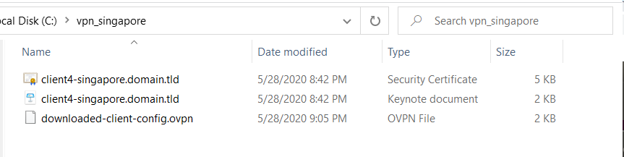  
     
     
   Ubuntu Linux  
   e.g  
   
2. For MAC/Linux only, please edit the OVPN (VPN configuration file) you downloaded above to point to the directory where the Key and Certificate are placed. Edit the last two lines in the file as shown below.

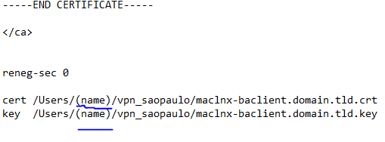

1. Download the VPN client appropriate for your Operating System .  
     
   Download using the appropriate link

|  |  |
| --- | --- |
| Operating System | Link |
| Windows | <https://aws.amazon.com/vpn/client-vpn-download/> |
| Apple Mac | <https://aws.amazon.com/vpn/client-vpn-download/> |
| Linux Ubuntu (18.04) | See details below to download using APT |

Downloading Windows or Mac   
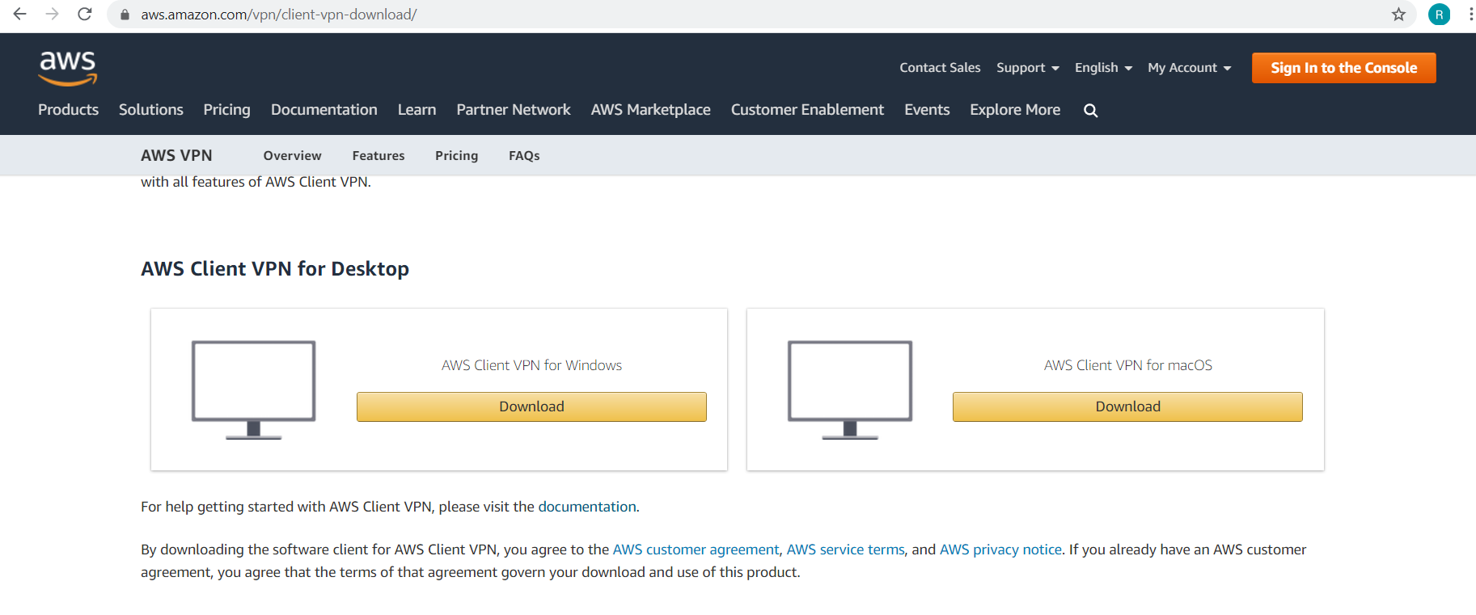

Ubuntu Linux  
This step is not required here

1. Install the VPN Client   
   Follow the instructions below for your Operating System  
     
   Windows  
   Execute the installation binary you downloaded  
     
   Clieck **Next** -> **I Agree** -> **Next** (to install) -> **Close**  
     
   Mac  
   Use the OS native App manager to install the client  
     
     
   Ubuntu Linux 18.04

|  |
| --- |
| **$ sudo apt-get install openvpn** |

e.g  
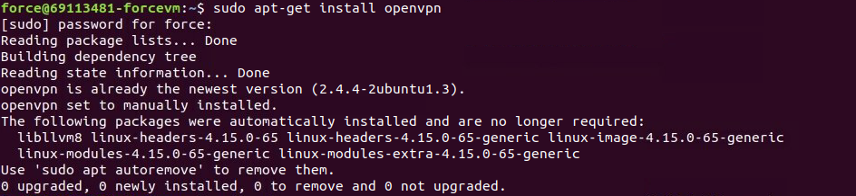

1. Run the VPN client   
     
   Windows  
   from the Desktop icon or from the Start menu   
   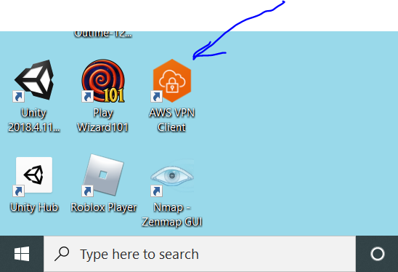  
     
   Mac  
   Open the AWS VPN Client app  
     
   Ubuntu Linux  
   This step is not required on Linux
2. Create a Profile for the VPN configuration you received.   
     
   This step is the same for Windows or Mac. It’s not required on Ubuntu Linux  
   Windows screen shots  
   **File - > Manage Profiles -> Add Profile**  
     
   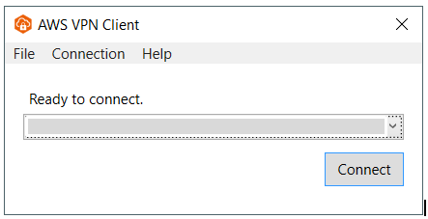  
     
   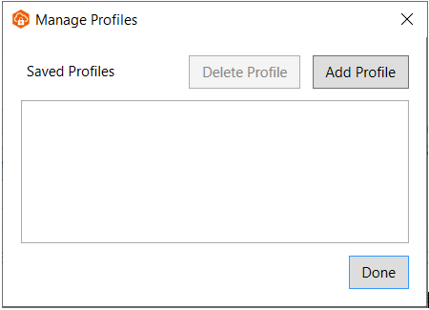  
     
   Enter a name for the profile ( e.g **singapore** ) and select the Configuration File   
   (e.g **C:\vpn_singapore\downloaded-client-config.ovpn** ) then **Add Profile**  
   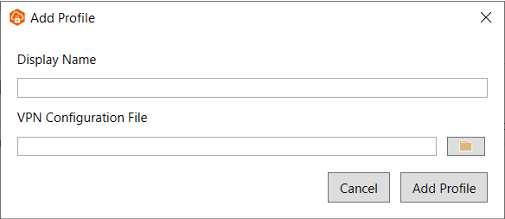  
     
   Mac Screen Shots  
     
     
   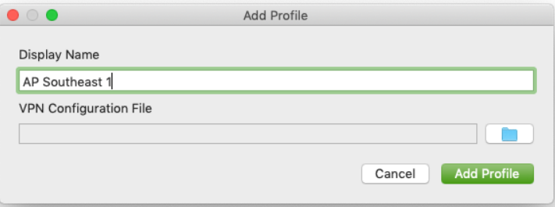
3. Establish the Connection to the VPN  
     
   Windows & Mac  
     
   Select the profile and Click **Connect**  
   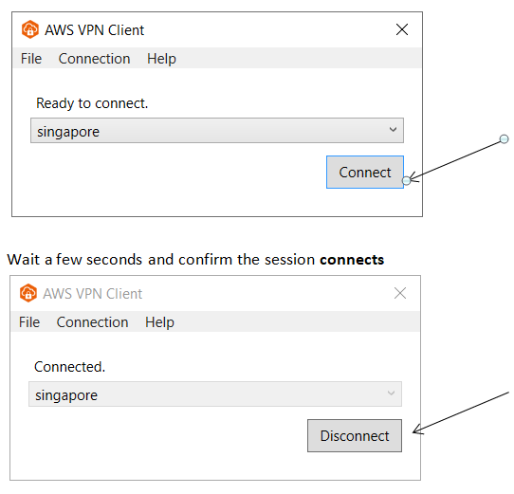  
   At this point the VPN connection is established and you can proceed to SSH into your AWS Linux system  
   Ubuntu Linux  
   Execute this command to connect to the VPN

|  |
| --- |
| $ cd ~/vpn_singapore  $ sudo openvpn –config downloaded-client-config.ovpn |

Note: This termina must remain open running the vpn. Open a separate terminal window for other work.  
e.g  
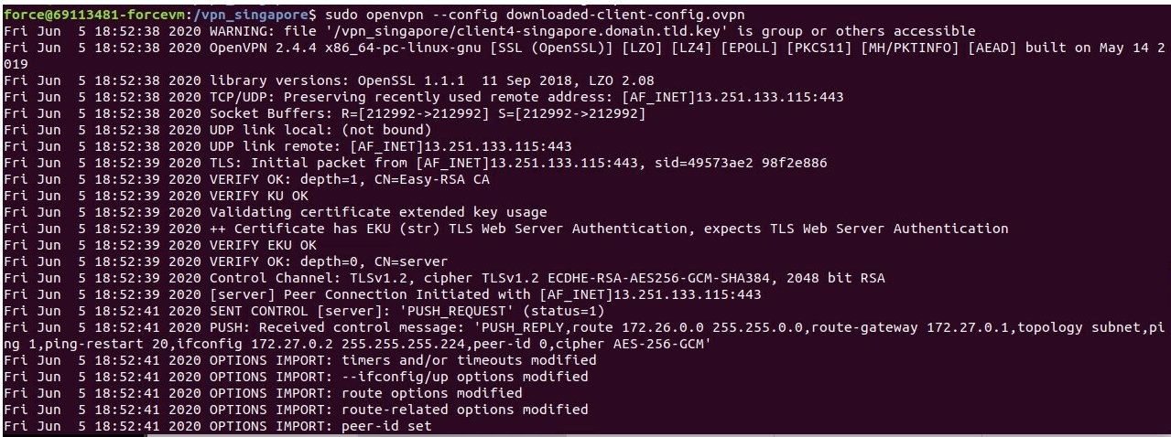  
  
NOTE:   
If for some reason you choose not to use the specified folder for the VPN files, then you will need to modify the downloaded-client-config.ovpn file. Simplye modify the last two lines which specify the location of the certificate and key files. For Windows make sure to follow the syntax present using “\\” to separate the paths as in “c:\\vpn_singapore”

1. Connecting to your EC2 Linux instance via SSH  
     
   Windows  
   Use Putty to connect to the AWS Linux host. See [these](https://www.ssh.com/ssh/putty/windows/) instructions for reference Use the host **ssh key** provided to you.  
     
   Mac and Ubuntu Linux  
   Use the OS native ssh client to connect to the AWS Linux hosts. Use the host **ssh key** provided to you.

SSH Syntax:

|  |
| --- |
| $ ssh -i <key_name> ubuntu@<host_ip_address> |

eg.  
